**DAY12- ASSIGNMENT**

BATCH NAME: SAP ABAP HANA

NAME: PAMPANABOINA VANDANA

EMP ID:46255266

EMP EMAIL ID: PAMPANABOINA.VANDANA@CAPGEMINI.COM

INTERFACE IN SFP

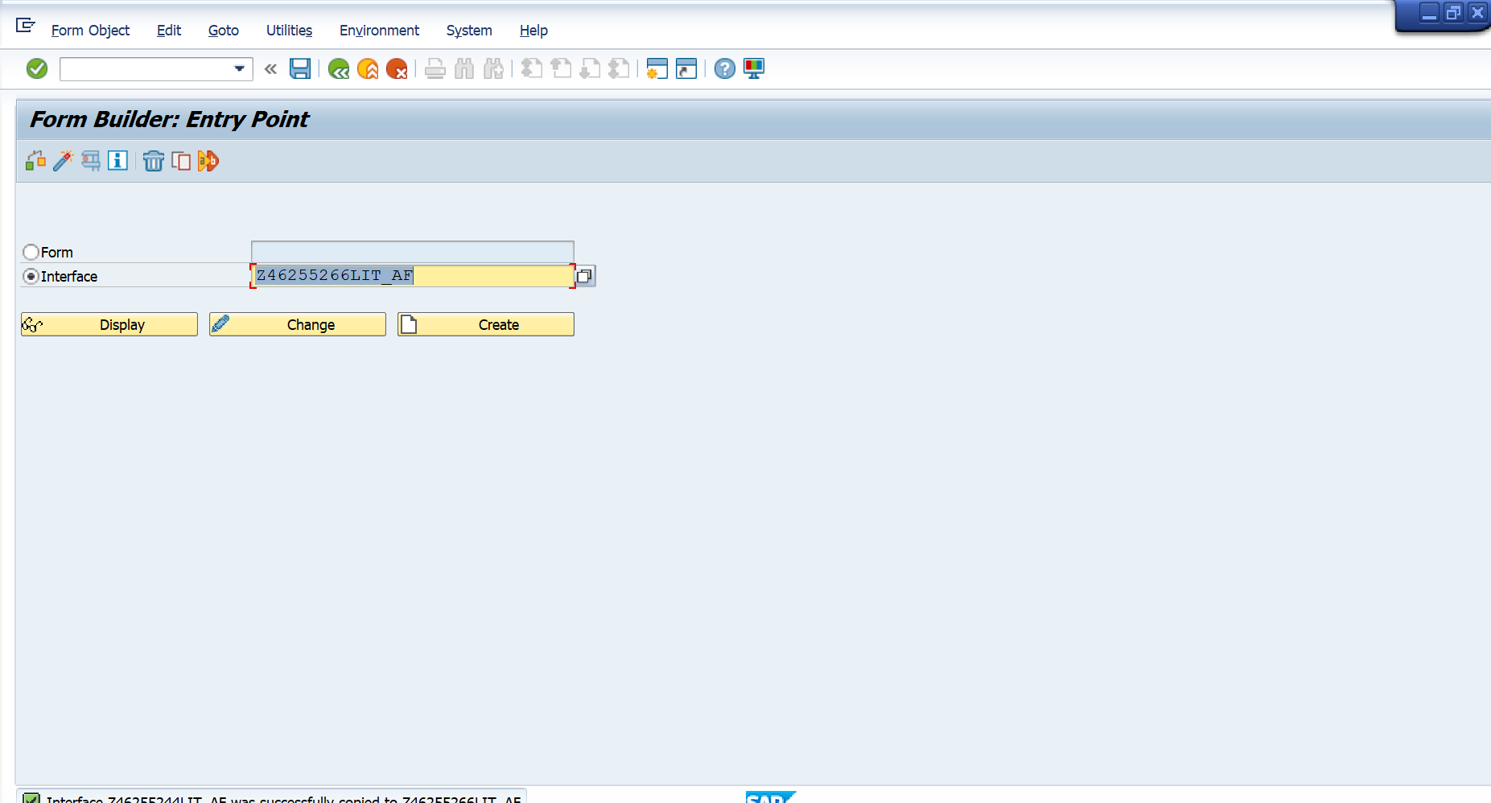

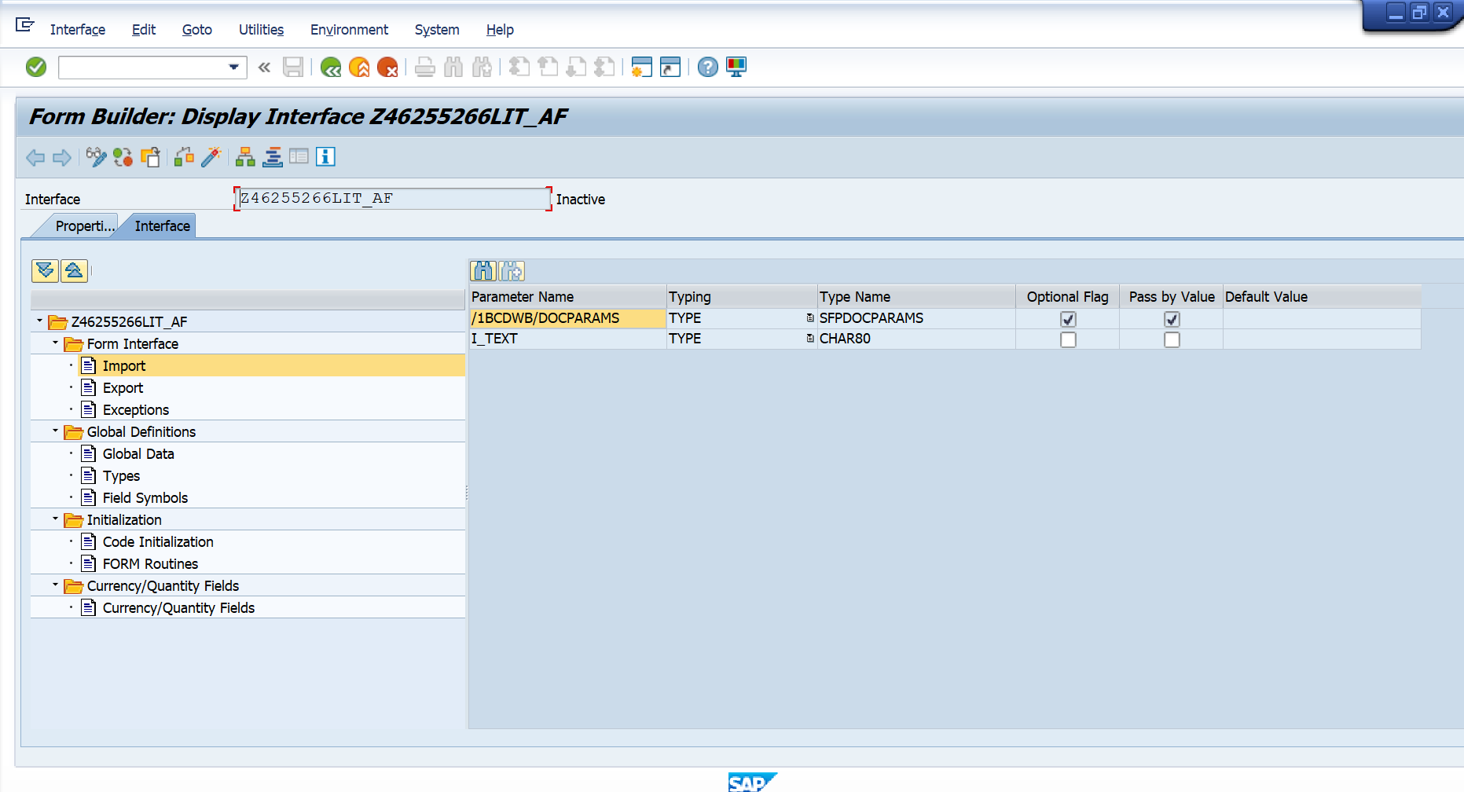

S_IMAGE FOR DATA DECLARATION OF SE-78 IMAGE

IT_TAB FOR IT_FLIGHT FIELDS DATA

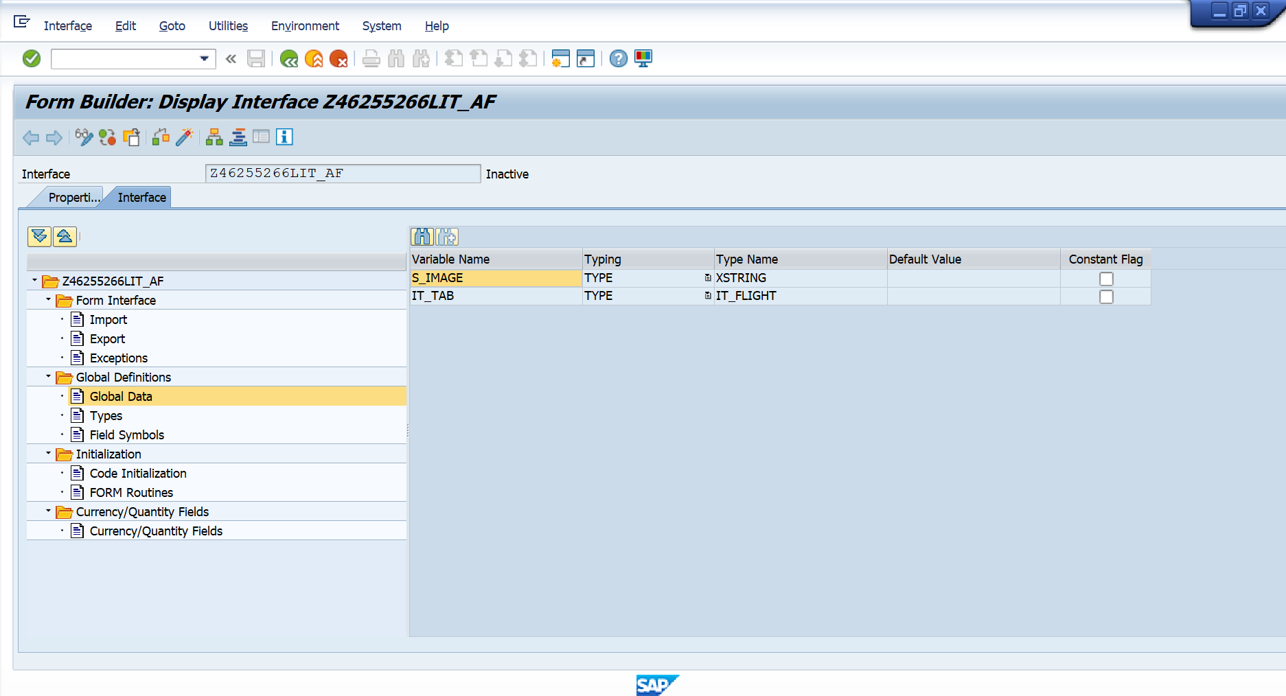

CODE FOR SFLIGHT DATA AND IMAGE

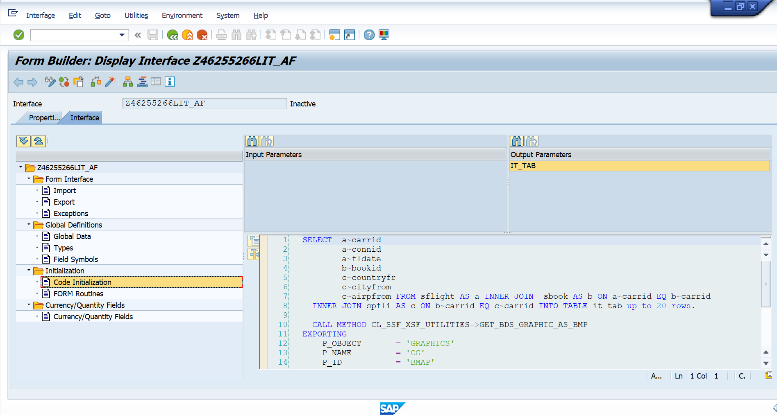

CREATION OF ADOBE FORM WITH CREATED INTERFACE

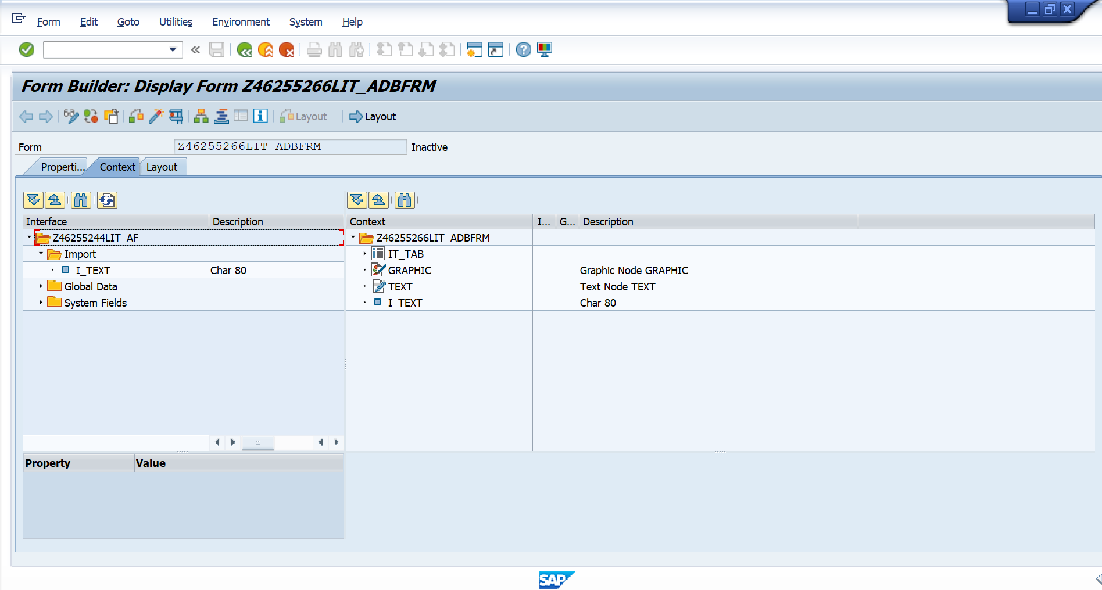

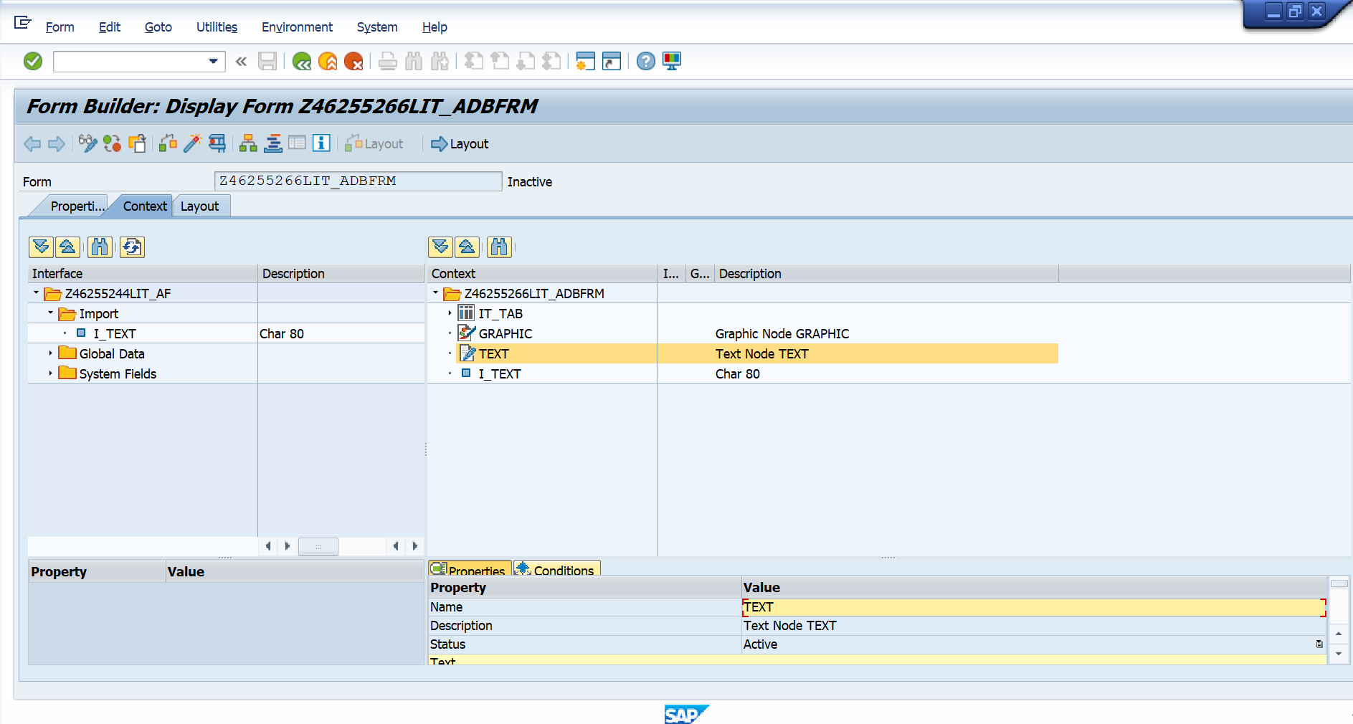

NOW GO TO LAYOUT

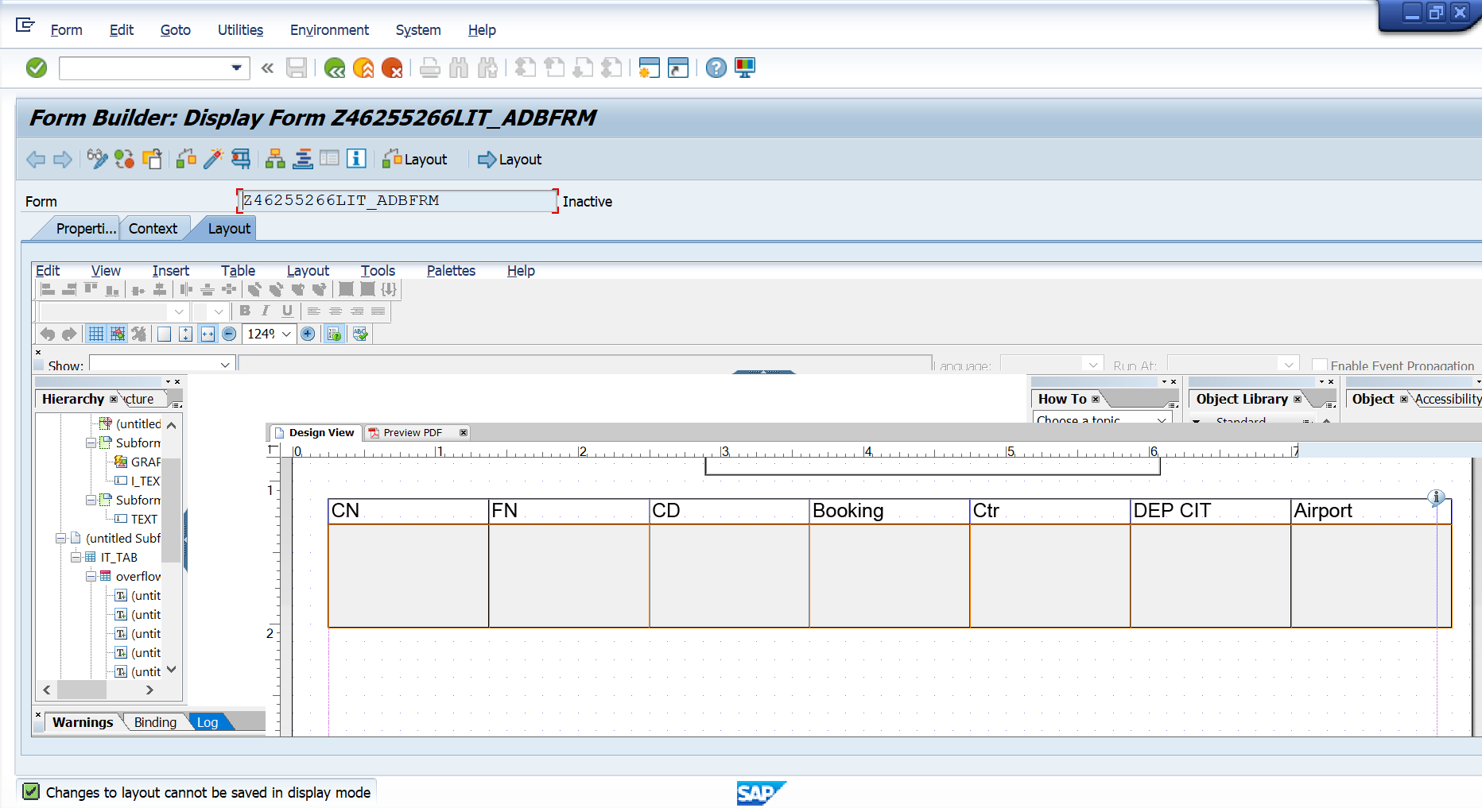

RESTRICTION LOGO AND DYNAMIC TEXT TO 1ST PAGE USING JS

var curpage = $layout.page ( ref ( $ ) )

       if ( curpage ne 1 ) then

       $.presence = "hidden"

       endif

RESTRICTION FOOTER TO LAST PAGE USING JS

        var curp = $layout.page ( ref ( $ ) )

        var totalp = $layout.pageCount()

        if ( curp ne totalp ) then

        $.presence = "hidden"

        endif

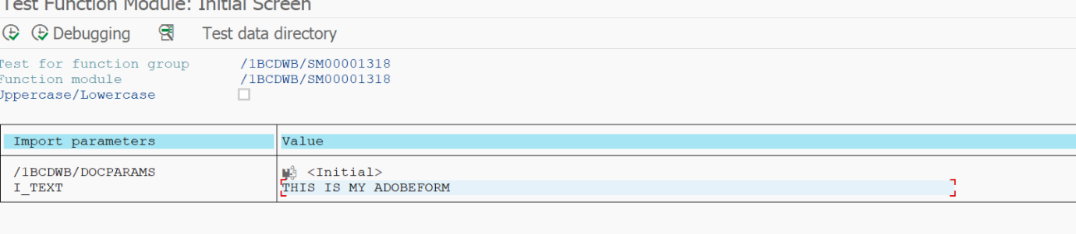

**OUTPUT:**

